AP Calc WS#1 Prerequisites 1 for Calculus Name: _________________

1. Find the value of y that corresponds to x = 3 in y = -2 + 4(x - 3) _________   
 (6 ways to use calculator)

Find the value of x that corresponds to y = 3 in y = 3 - 2(x + 1) ________

(Algebra and Graphing)

For x = 5 and y = 2 then $m=\frac{y-3}{x-4}$ = ? ____ For x = -1, y = -3 then =? _____

2. Find the x-intercept and y-intercepts of the following

y = 2x – 5 3x – 4y = 5 y = 6x2 – 4x – 7

3. What are Fahrenheit, Celsius and Kevin Temperature (Ask Siri). Write the conversion equation among these three. Convert 20oC, 95oF and 315oK into the other two.

4. Solve for x

x2 < 16 x(x – 2) > 0 9 – x2 > 0

5. If f (x) = x2 + 1 and g(x) = 2x – 1. Find the following

a. f o g (2) b. f o g (x) c. g o f (x)

d. f + g (x) e. fg(x) f.

6. Graph the piecewise functions and show me the last two for stamp __________________

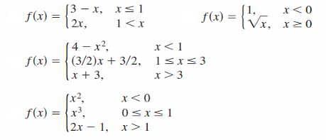

Write a piecewise for the following functions then graph it in calculator and desmos apps

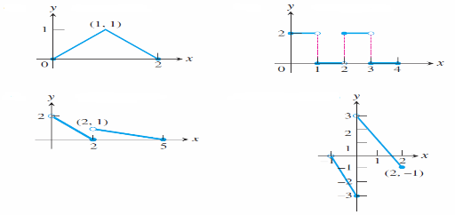

7. Determine whether the function is even {f(x) = f(-x) symmetry about y-axis}, odd {f(-x) = -f(x) symmetry about the origin} or neither

y = x4 y = x + x3 y = x + x2

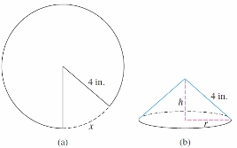8. Begin with a circular piece of paper with a

4-in. radius as shown in (a). Cut out a sector with an arc length of x. Join the two edges of the remaining portion to form a cone with radius r and height h, as shown in (b).

a. Express the radius r as a function of x.

b. Express the height h as a function of x.

c. Express the volume V of the cone as a function of x.

9. Write the exponential function f(x) = a bx that pass through the two points

a. (1, 4.5), (-1, 0.5) b. (1, 1.5), (-1, 6)

10. The half-life of a certain radioactive substance is 8 hrs. There are 5 grams present initially. When there will be 1 gram remaining?